Forgot Windows 7 Password, Ways to Find Windows 7 Password
Article Source: http://recoverlostpassword.com/article/forgot-windows-7-password.html
Question: I forgot my Windows 7 Password and now I am not able to login into my Win 7 system. I am looking for ways to find my forgotten windows 7 password and I really don’t know how to do. Someone please help, Thanks in advance.
Answer: forgetting windows 7 password? Take it easy, there are several ways you can try to find your forgotten windows 7 password.

Method one: Use beforehand Windows 7 password reset disk

When you first time set a password for your Windows 7, if you are proactive to create a password reset disk in case of forgetting windows 7 password. Congratulation! It is the time to use your prepared windows 7 password reset disk to reset the forgotten windows 7 password. Follow the steps to reset windows 7 password with your disk:
- When you type a wrong password at the login screen, you will see “The username or password is incorrect” error. Click OK to see Reset Password… option
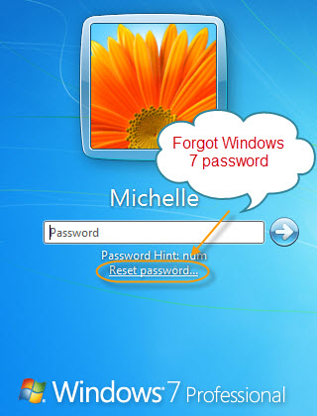
- Insert your password reset disk and then click on the Reset Password… option to open the Password Reset Wizard. Click next button to continue.
- Select the password reset disk (that you used while creating the reset disk) from the drop down box. Click next to proceed to the next step.
- Enter a new password and then type the password again to confirm.
- Click the next button and then click the finish button to close the wizard.
- Now enter the new password in password box in the login screen to login to your user account.
If you have forgotten win 7 passwords but didn’t create a password reset disk, then method one wouldn’t work for you. Keep reading, below lists a well-known method for you to reset win 7 passwords after you forgot Windows 7 password.

Method two: Create a bootable password recovery disk
Forgot win 7 password and don’t have a password reset disk, SmartKey Windows Password Recovery is a secure software designed to create a bootable password recovery disk to reset a lost or forgotten Windows 7 password for any version of Windows, including Windows 7/Vista/XP /2000/NT and Windows server 2008/20003.
Things you need:
1. Relax and trust this software can help you out of the trouble
2. A blank CD/DVD or USB flash drive
3. A bootable CD/DVD-ROM drive..
4. Go to SmartKey Password Recovery Official site.
The step-by-step guideline:
Step 1: Download Windows Password Recovery Tool
Login into a computer that can link to the Internet, Google Search “SmartKey Windows Password Recovery” and then download Windows password recovery tool from SmartKey password recovery official site. The free download link is available here: http://www.recoverlostpassword.com/products/windowspasswordrecoery.html
Install the software with default options.
Step 2: Create a Windows 7 password reset disk

1. Insert a blank CD/DVD disk into the CD-ROM drive or an USB flash drive into a USB port.
2. Run the software, choose the password recovery mode, you can choose to reset windows local account password or reset windows domain administrator password.
Note: Only Windows Password Recovery Enterprise version has the function to reset windows domain administrator password
3. Choose what windows password reset device you have inserted before, click Burn.
Note: Only Windows Password Recovery Enterprise version and Windows Password Recovery Professional version have the function to burn the software to USB flash drive.
4. Click Burn to start burning. 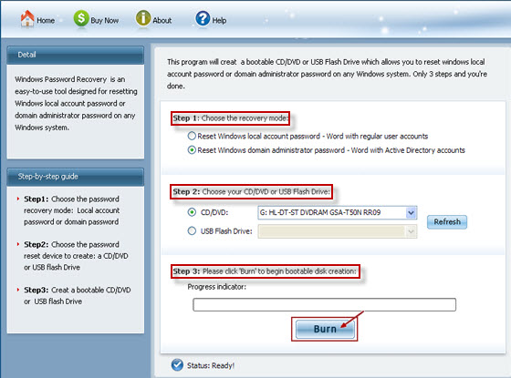
Step 3: Reset forgotten Windows 7 password
1. Insert newly created windows 7 passwords reset disk and reboot your computer.
NOTE:
To reboot your PC with a CD/DVD disk or USB Flash Drive , it's necessary to set BIOS to boot from the CD/DVD-ROM or USB flash drive.
3. Choose the Windows installation to be processed:
4. Click Reset button to reset forgotten Windows 7 password to Re123456.

Now your forgotten Windows 7 password has been reset so that you can log on with the new password. The created Windows 7 password recovery bootable disk can safely and easily reset forgotten Windows 7 password, it saves you much more time and trouble than reinstalling Windows OS, and won't lose any data on your computer.

